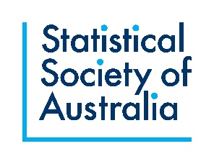
Statistical Society of Australia Diamond Jubilee Fellowship
Application Form
The entire form should be 3 pages or less. Please do not change the margins, line spacing or font size. You can delete explanatory text in italics.

Name:
Email address:
Please tick the following to confirm your eligibility for the SSA Diamond Jubilee Fellowships:
I am a current non-student member of the Statistical Society of Australia and have been a member of the Society for at least two years.
I am within 10 years of the award of my highest degree (allowing for career disruptions) and, if employed at an academic institution, I am employed at Level C or lower.
I have not received a fellowship from the ARC (e.g. DECRA) or NHMRC (e.g. Investigator Grant), nor have I received any other major grant as the lead chief investigator.

What activities will the Diamond Jubilee Fellowship support?
Please describe the activities and how these will boost your career.

Track record in relation to your planned activities.
Please describe your career in statistics/data science so far and how your track record sets you up for success in the activities described above. If you have any career disruptions, please note them briefly here, along with the total length of all disruptions (e.g. “I worked 0.5FTE in 2019 and was on sick leave for three months in 2020, leading to a total disruption of 0.75 years.”) Please note that sensitive details about these disruptions are not required.

Diamond Jubilee Fellowship Budget
Diamond Jubilee Fellowships provide up to $5000 to be spent on career-boosting activities. In the table below please provide a tentative budget, adding rows as required.
Item | Expected expense
Total Requested (Maximum $5000)

Please send the completed form to eo@statsoc.org.au.

